Lesson 20: Solution Sets to Equations with Two Variables

Classwork

Exercises

* 1. Circle all the ordered pairs $(x,y)$ that are solutions to the equation .

* 1. How did you decide whether or not an ordered pair was a solution to the equation?
  2. Discover as many additional solutions to the equation $4x-y=10$ as possible. Consider the best way to organize all the solutions you have found. Be prepared to share the strategies you used to find your solutions.
  3. Now, find five more solutions where one or more variables are negative numbers or non-integer values. Be prepared to share the strategies you used to find your solutions.
  4. How many ordered pairs $(x,y)$ will be in the solution set of the equation $4x-y=10$?
  5. 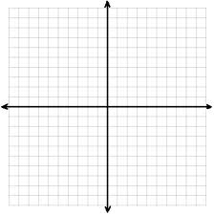Create a visual representation of the solution set by plotting each solution as a point $(x,y)$ in the coordinate plane.
  6. Why does it make sense to represent the solution to the equation $4x-y=10$ as a line in the coordinate plane?

1. The sum of two numbers is $25$. What are the numbers?
   1. Create an equation using two variables to represent this situation. Be sure to explain the meaning of each variable.
   2. List at least six solutions to the equation you created in part (a).
   3. Create a graph that represents the solution set to the equation.
2. Gia had $25$ songs in a playlist composed of songs from her two favorite artists, Beyonce and Jennifer Lopez. How many songs did she have by each one in the playlist?
   1. Create an equation using two variables to represent this situation. Be sure to explain the meaning of each variable.
   2. List at least three solutions to the equation you created in part (a).
   3. Create a graph that represents the solution set to the equation.
3. Compare your solutions to Exercises 3 and 4. How are they alike? How are they different?

Lesson Summary

An *ordered pair* is a *solution* to a two-variable equation when each number substituted into its corresponding variable makes the equation a true number sentence. All of the solutions to a two-variable equation are called the *solution set*.

Each ordered pair of numbers in the solution set of the equation corresponds to a point on the coordinate plane. The set of all such points in the coordinate plane is called the *graph of the equation.*

Problem Set



5



4



3



2

1

1. Match each equation with its graph. Explain your reasoning.
$y=5x-6$

$x+2y=-12$

$2x+y=4$

$y=3x-6$

$x=-y-4$

2. Graph the solution set in the coordinate plane. Label at least two ordered pairs that are solutions on your graph.

$10x+6y=100$

$y=9.5x+20$

$7x-3y=21$

$y=4(x+10)$

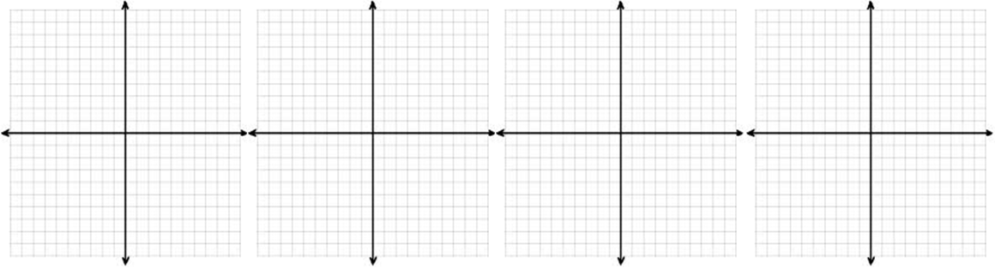

1. Mari and Lori are starting a business to make gourmet toffee. They gather the following information from another business about prices for different amounts of toffee. Which equation and which graph are most likely to model the price, $p$, for $x$ pounds of toffee? Justify your reasoning.

Graph 1 Graph 2



|  |  |
| --- | --- |
| **Pounds, $x$** | **Price, $p$, for $x$  pounds** |
| $$0.25$$ | $$\$3.60$$ |
| $$0.81$$ | $$\$6.48$$ |
| $$1$$ | $$\$7.20$$ |
| $$1.44$$ | $$\$8.64$$ |

Equation A: $p=5x+2.2$

Equation B: $p=7.2\sqrt{x}$